
1. Improvements include being able to edit a complete job only by Admin and Scheduler only.
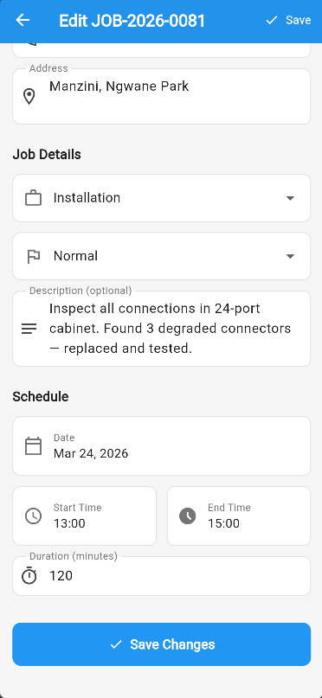

2. Vehicles can now be deactivated if they are not available or at the garage, delete vehicle and add new vehicle.
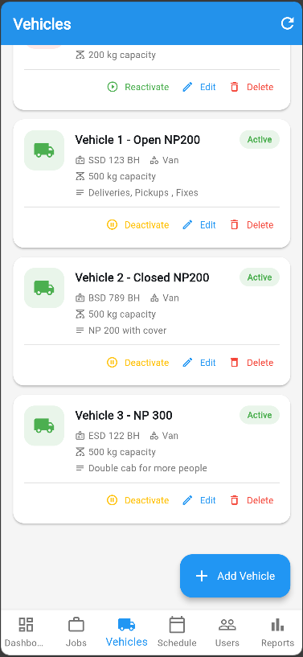

3. Adding of System Users
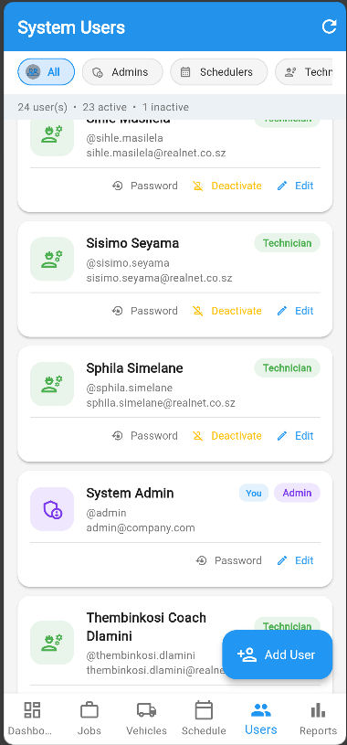
4. Reports are now available including an all jobs , completion rate, cancel rate and jobs pending. The total vehicles , technicians and also the job daily volume.
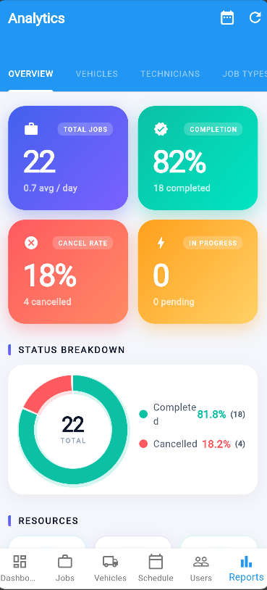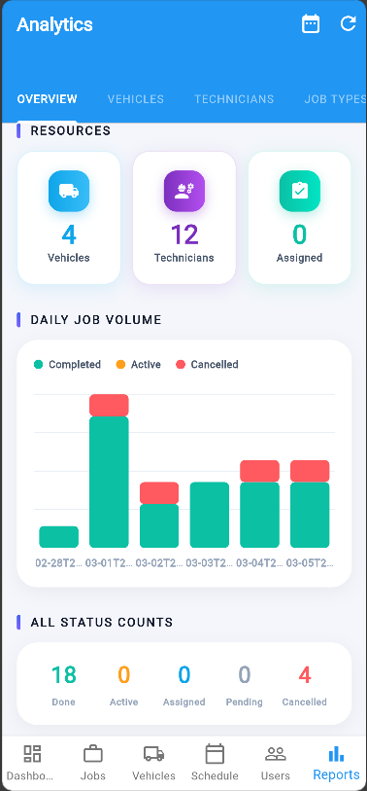

A custom range to show a report from a particular time period
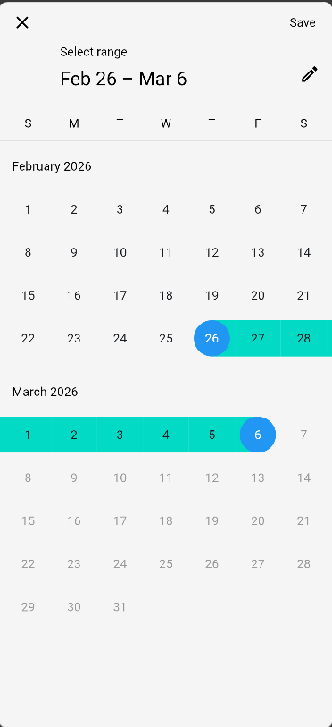

5. A vehicle utilization report to show jobs done by vehicles on a particular time period.
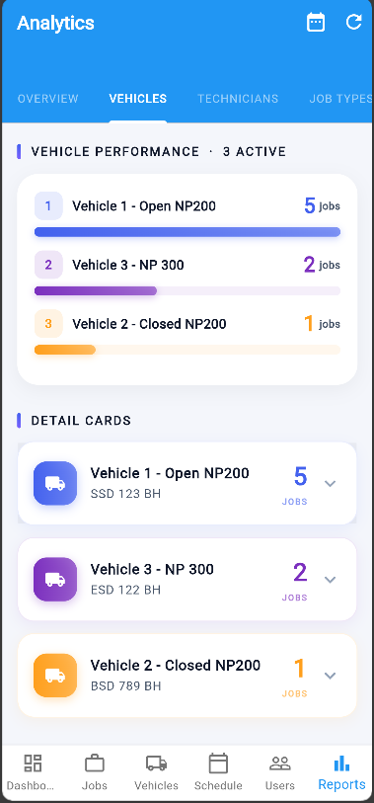
6. A technician leaderboard to show Jobs done
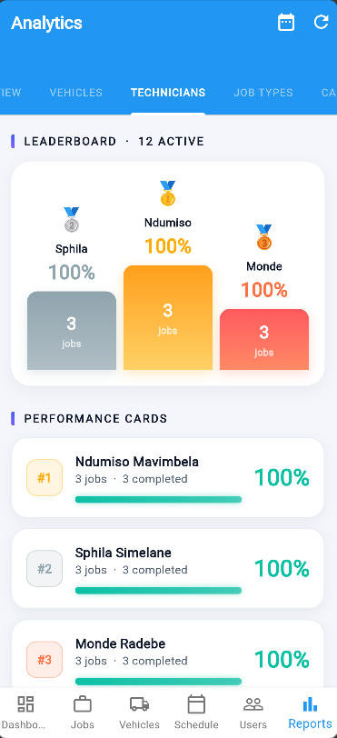
7. A distribution of the job types
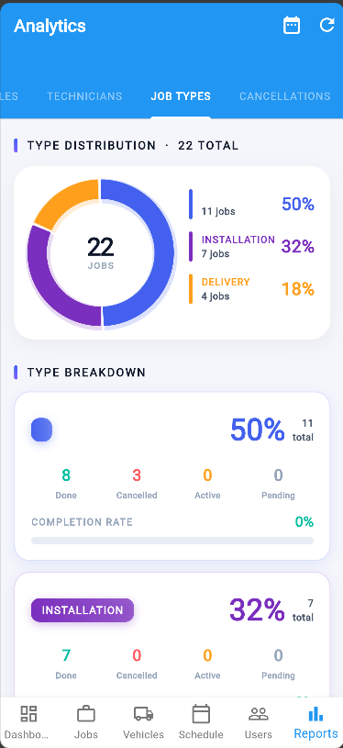
8. Cancellation report and why they were cancelled
